### **Creating Offboarding Workflow**

1. Go to the top right **“Setup”** menu **>** **“Forms, Workflows & Template”** sub-menu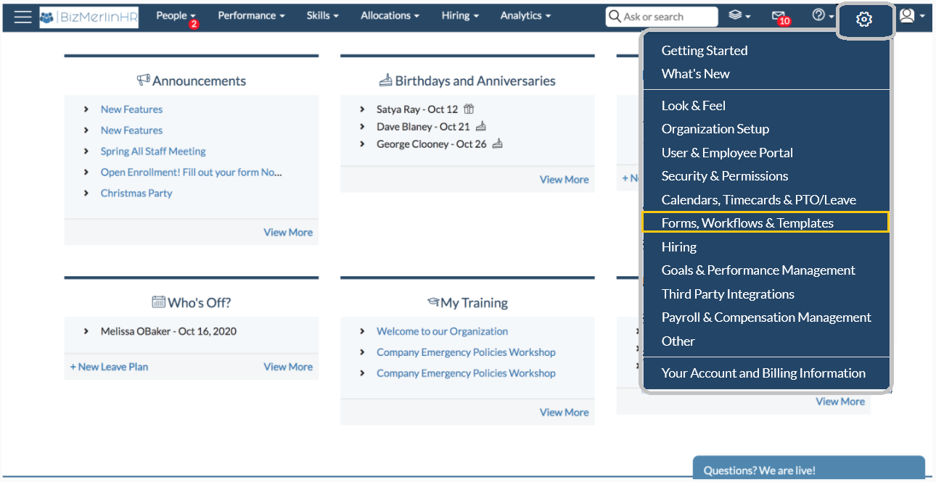
2. Go to **Workflows section** and click on **“Workflows”**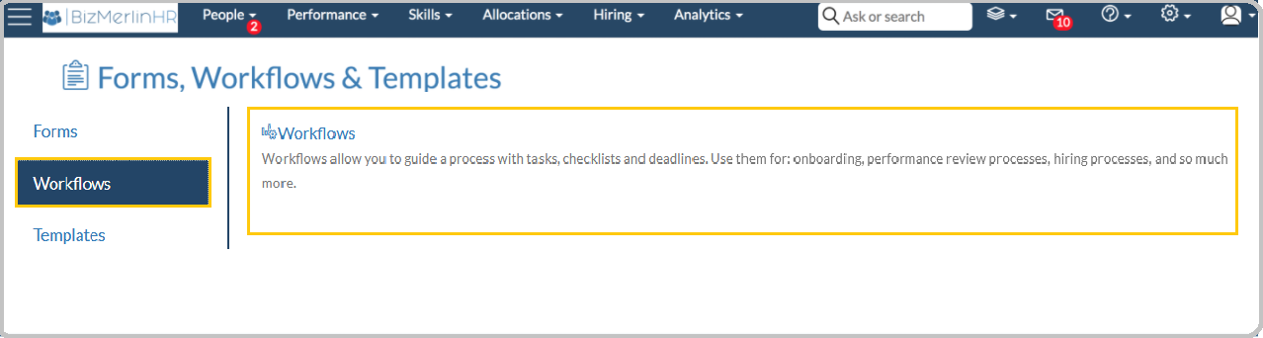
3. To create a new one, click on **“New Workflow”** button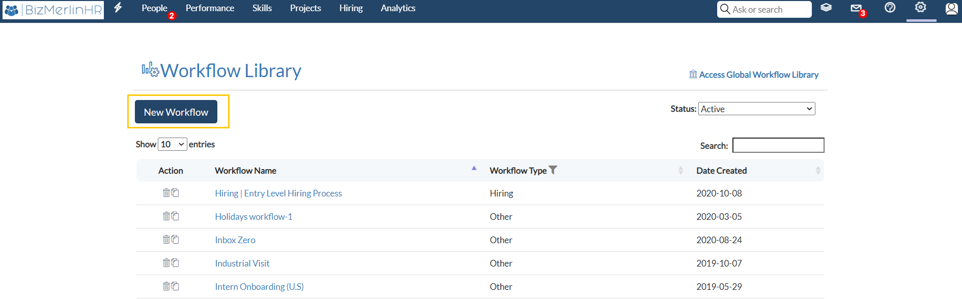
4. Fill out the details of the workflow, including:
5. Select Worktype as **Offboarding**
6. **Workflow Applicable to:** Specify what type of object this workflow will be applicable to – user, candidates- , or if it is a “performance review workflow. For **Offboarding** workflows, select “**User**“.
7. Click on **“Save Workflow”**

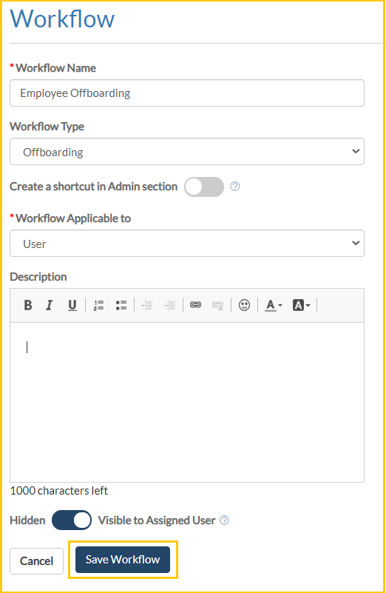

Learn more on [‘How to create a Workflow?’](https://www.bizmerlin.com/articles/how-to-create-a-workflow/)

### 

### **Add Phases and Tasks to the Workflow**

1. To create the first phase in your workflow you need to edit the **“Sample Phase”**. For editing click on the edit button on the right corner of the phase.

NOTE: For creating more phases you need to click on “Add phase” as shown below.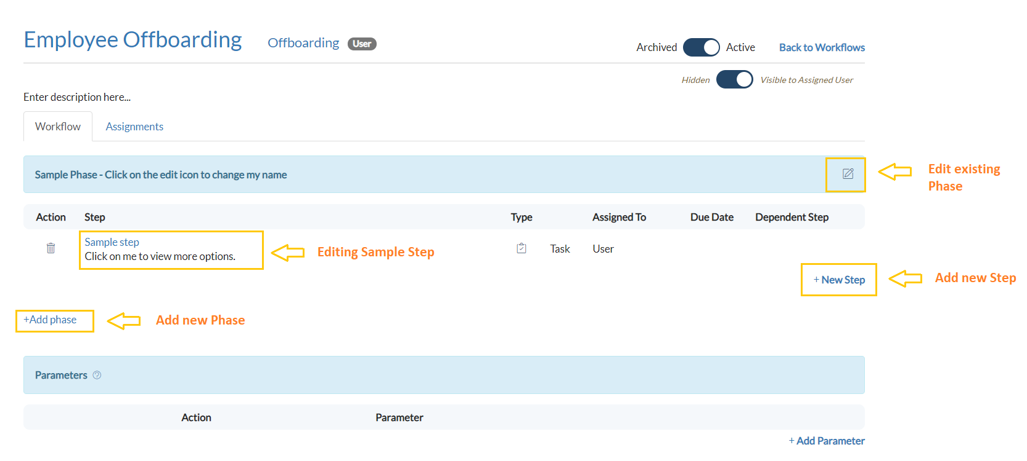

1. Add the name for your phase and click on **“Save Phase”**. Now a phase gets created.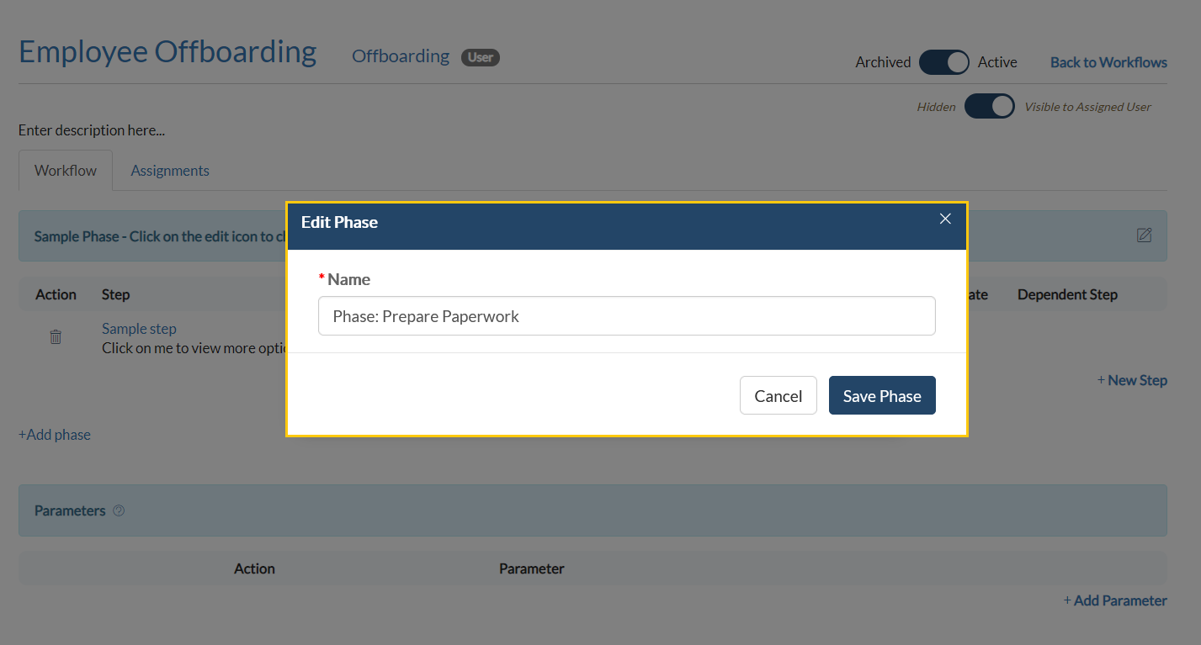
2. To add sub tasks/ steps within the Phase. Either click on the **“Sample Step”** (Only in case you are editing a sample created at the time of workflow creation) or go to **“New Step”**
3. A new pop-up will be opened after clicking on a new Step or Sample Step. Fill all the details required, including:
4. **“Task”**: Select which kind of task you are performing like email, document to fill/sign etc.
5. **“Assign the step”**: Select appropriate user to whom the step is to be assigned, like select option as **Specific user** in case you want to assign this task to particular user or **User group** in case you want to assign that task to a specific user group or department.

Refer to How to create a “User Group”?

1. Click on **“Save Step”**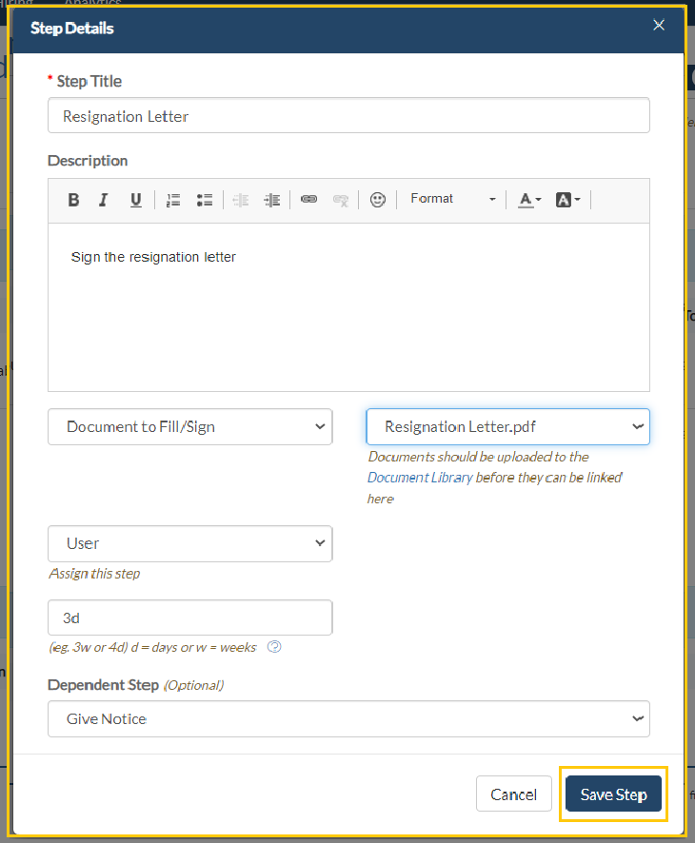

### **How to create a “User Group”?**

Suppose we have a step in which we require to assign to a group of users. Then we need to create a user group and then use that user group where required.

To create a User Group:

1. Go to the top right **“Setup”** menu **>** **“Security and Permissions”** sub-menu

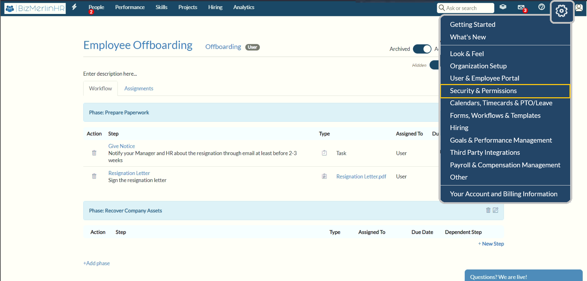

1. Click on **“Permissions”** > **“User Groups”**

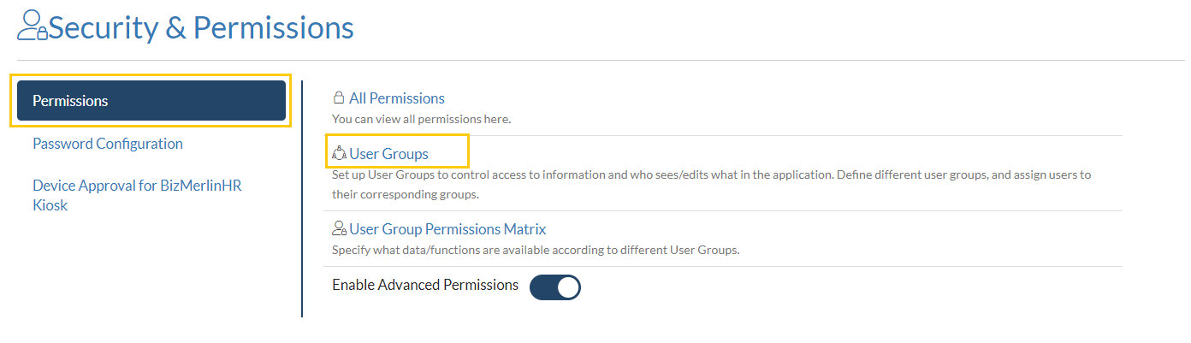

1. Click on **“New User Group”** to add a new group.

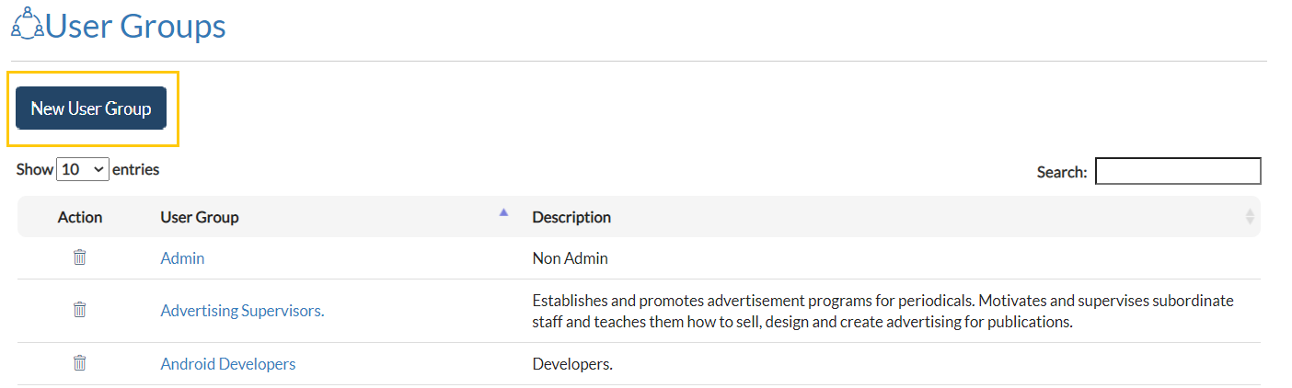

1. Add the details of the group including group name and description and follow with clicking on the **“Submit”** button.

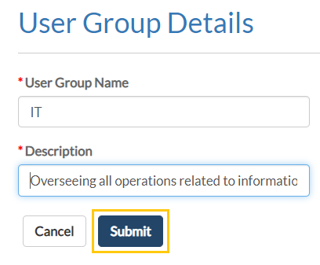

1. A new group is created and now we can add members in the group. You can add members one-by-one or add members in bulk.
2. **“Add Member”**: Adding a single member with Org Unit, Profile and Location details.
3. **“Add Members in Bulk”**: Make Selection based on Org Unit, Profile and Location details > Confirm members using checkboxes. You will be Acknowledged after adding members to the group.

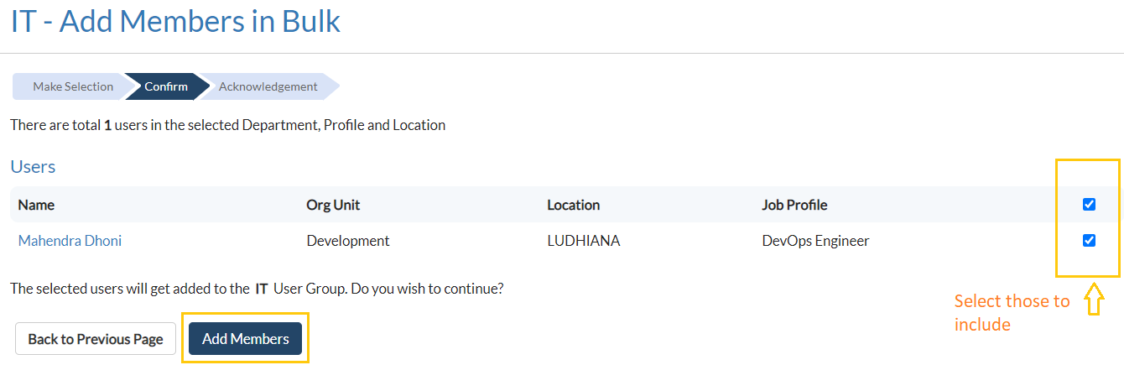

1. Now you can use the group created in Workflow steps by selecting the **“Assign this Step”** option to **“User Group”** and then **“Select User Group”** that you have created.

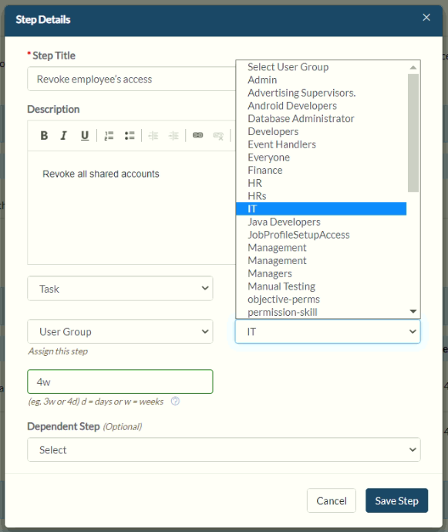

### **Offboarding | Employee** *(Sample Offboarding Workflow)*

* **Phase:** **Prepare Paperwork:** 
  + **Give Notice:**  Notify your Manager and HR about the resignation at least before 2-3 weeks
  + **Resignation Letter:** Sign the resignation letter
  + **Payroll:** Final Pay-check with documentation
* **Phase:** **Recover Company Assets:** 
  + **IT equipment:**  Submit your laptop and other IT equipment’s
  + **Access/ID card:** Submit your ID card to assignee
* **Phase:** **IT Permissions and Access** 
  + **Revoke employee’s access:** Revoke all shared accounts
  + **Update directory and org chart:** Remove user from the directory and update the organization chart
* **Phase: Exit interview** 
  + **Schedule exit interview:** Schedule an exit interview with the HR
  + **Feedback Form:** Fill the feedback form

Refer to Offboarding Example Workflow to have a look at “How the complete workflow will look like?”

### 

### **Offboarding Example Workflow**

